

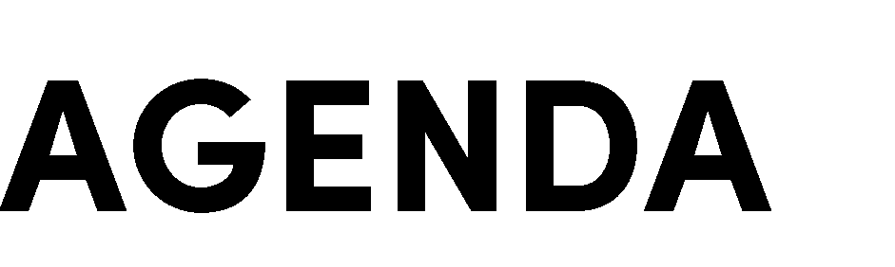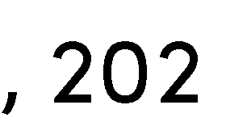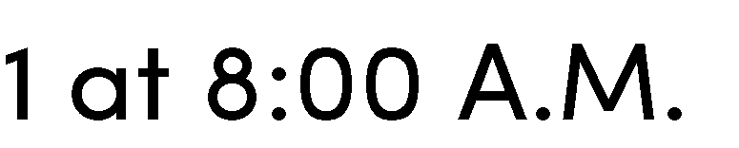

|  |  |  |  |  |  |  |
| --- | --- | --- | --- | --- | --- | --- |
| Jon Kanagy | Gretchen Stranzl McCann | Bruce Barge | Ashley Anderson Bennett | Rainer Hoenicke | Jim Lincoln | Bill Pramuk |
| **President** | **Vice President** | **Director** | **Director** | **Director** | **Director** | **Director** |

|  |  |  |  |
| --- | --- | --- | --- |
| Lucas Patzek | Anna Mattinson | Shana Bagley | Tracy Schulze |
| **Executive Director** | **District Secretary** | **District Counsel** | **Auditor-Controller** |

The Napa County Resource Conservation District (“Napa RCD” or “District”) will hold a regular meeting of its Board of Directors on Thursday, December 9, 2021 at 8:00 A.M. In accordance with California Assembly Bill 361, the Governor’s proclamation of a state of emergency due to COVID-19, and local officials’ recommendation for continued remote attendance at public meetings, this meeting will be streamed live via Zoom links. You can participate in the meeting as follows:



Via Zoom videoconference at: <https://zoom.us/j/332821538?pwd=cmp4eUxHNEl1UGJxWFpoTGIzRENlZz09> Meeting ID: 332 821 538, Password: 322739

Via teleconference at:

669-900-9128, Meeting ID: 332 821 538

We will accept written public comments received by 4 P.M. on Wednesday, December 8, 2021 sent by email to [Lucas@NapaRCD.org](mailto:Lucas@NapaRCD.org), and we will provide time for oral public comments at the meeting. All comments will be considered a public record and will be put into the meeting record. Requests for disability related modifications or accommodations, aids or services must be made to the District office no less than 24 hours prior to the meeting date by contacting 707-690-3110, [Anna@NapaRCD.org](mailto:Anna@NapaRCD.org). All materials relating to the agenda are available for public inspection at the District office Monday through Friday, between the hours of 8:00 A.M. and 5:00 P.M., except for District Holidays. The agenda is available online at: <http://naparcd.org/>



1. **Roll call –** The meeting is to be called to order by the Chair at 8:00 A.M., and the District Secretary will take attendance.
2. **Approval of the agenda –** The Board will consider approval of the agenda for this meeting.
3. **Adoption of Resolution No. 2021-07 –** The Board will consider approval of a resolution making findings in accordance with AB 361 and Government Code Section 54953, authorizing remote teleconference meetings of the legislative bodies of the District.
4. **Approval of meeting minutes –** The Board will consider approval of minutes from the November 18, 2021 regular meeting and the December 2, 2021 special meeting.
5. **Ratification of District bills –** The Board will review and ratify bills approved by the Executive Director.
6. **Approval of District bills –** The Board will review and consider approval of the District bills for November 2021.



In this time-period, anyone may comment to the Board regarding any subject over which the District has jurisdiction. No comments will be allowed involving any subject matter scheduled for hearing, action, or discussion as part of the current agenda other than to request discussion on a specific consent item. Individuals are requested to limit their comment to three minutes. No action will be taken by the Board as a result of any item presented at this time.



1. **Presentation 1 –** Jamison Crosby, Natural Resources Conservation Manager for Napa County, will present on the Draft Groundwater Sustainability Plan for the Napa Valley Subbasin.
2. **Presentation 2 –** Martin Perales, Environmental Scientist II for Napa RCD, will present on the 2021 Fish Barrier Assessment.



All items on the consent calendar are considered ministerial or non-substantive and subject to a single motion approval. With the concurrence of the Chair, a Board member may request discussion of an item on the consent calendar.

# **Authorize Executive Director to enter into agreement with Napa County Farm Bureau to assist with implementing the Monitoring Plan for the Waste Discharge**

**Requirements for Vineyard Properties in the Napa River and Sonoma Creek Watersheds.**

Napa RCD prepared the Monitoring Plan for the Waste Discharge Requirements for Vineyard Properties in the Napa River and Sonoma Creek watersheds, which was submitted to the San Francisco Bay Regional Water Quality Control Board in July 2020, and subsequently approved. The Napa County Farm Bureau is the designated Third-Party program responsible for fee-collection and implementing the Monitoring Plan on behalf of vineyard owners, and desires to hire Napa RCD to oversee implementation of the Monitoring Plan. This Agreement is estimated to be for $400,000 with an expiration date of July 1, 2024.

# **Authorize Executive Director to enter into agreement with Bark Media to assist Napa RCD, Sonoma RCD, Gold Ridge RCD, and Marin RCD in developing strategic communications for regenerative agriculture programming in the North Bay.**

Napa RCD partnered with RCDs in Sonoma and Marin Counties to prepare a funding request to a private foundation to assist with coordinating of shared messaging platform for regenerative agriculture programming in the North Bay. The foundation approved the request, and RCDs subsequently prepared an RFP for marketing and communications services, for which they received four proposals. The RCDs selected Bark Media to provide the services. This Agreement is for $74,000 and shall expire on July 1, 2023.

# **Authorize Executive Director to travel to the 2022 Annual Meeting of the National Association of Conservation Districts (NACD).**

NACD's 2022 Annual Meeting is occurring on February 12-16, 2022 in Orlando, Florida. The Executive Director was awarded a meeting stipend to cover airfare, lodging, and conference registration to present on Technical Assistance grant outcomes.



1. **Governance Committee update.** *Bruce Barge & Lucas Patzek*

Discuss [Board Personal Action Plans](https://forms.gle/GA2J5mt9xyZeihMU7) intended to help guide activities involving board and staff throughout the year. Discuss next steps from the Special Board Meeting.

1. **Huichica Creek Vineyard update.** *Lucas Patzek*



1. **Review and discuss District financial reports.** *Anna Mattinson*

Accounts receivable and cash flow reports will be presented.

# **Discuss the Regional Forest and Fire Capacity Grant Program, ratify Agreement No. 3020-1005 with Department of Conservation (DOC), and authorize Board President to sign documents related to this agreement.** *Lucas Patzek*

DOC’s Regional Forest and Fire Capacity Program seeks to increase regional capacity to prioritize, develop, and implement projects that improve forest health and fire resiliency, facilitate greenhouse gas emissions reductions, and increase carbon sequestration in forests throughout California. Block grants will be utilized by recipients to support regional implementation of landscape-level forest health projects consistent with the California Forest Carbon Plan and Executive Order B-52-18. Napa RCD will administer a block grant for the Inner Coast Region defined as Colusa, Lake, Napa, Solano, and Yolo Counties. Each county is considered a subregion, and each subregion is represented by a Collaborative Lead Member organization operating a forest health and wildfire resiliency program.

Board President Jon Kanagy executed Agreement No. 3020-1005 on November 17, 2021. The term of the agreement is November 15, 2021 through March 31, 2025, and the maximum amount is $2.96 million. Staff recommends that the Board authorizes its President to sign any additional documents related to this agreement, including subagreements with Collaborative Lead Members.



Lucas Patzek (Napa RCD Executive Director) will give an update on current NRCS and Napa RCD projects and activities. Rainer Hoenicke (RCD Director) will give an update on current CARCD projects and activities. Other Directors may also provide comments and updates.

