AGENDA
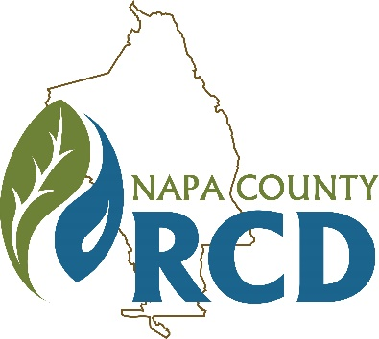 | Napa County Resource Conservation District  Special Meeting of the Board of Directors  When: Wednesday, August 5, 2020 at 3:00 P.M.  Where: Tele/videoconference
Jim Lincoln | Ashley Anderson Bennett | Rainer Hoenicke | Jon Kanagy | Beth Painter | Bill Pramuk | Gretchen Stranzl McCann
President | Vice President | Director | Director | Director | Director | Director

Lucas Patzek | Anna Mattinson | Shana Bagley | Tracy Schulze
Executive Director | District Secretary | District Counsel | Auditor-Controller

GENERAL INFORMATION
The Napa County Resource Conservation District (RCD or District) will hold a special meeting of its Board of Directors on Wednesday, August 5, 2020 at 3:00-4:30 P.M. Under the Governor’s Executive Orders N-25-20 and N-29-20, which suspend some requirements of the Brown Act (Gov. Code § 54950, et seq.) in an effort to mitigate the impact of COVID-19, this meeting will be held only via videoconference and teleconference. You can participate in the meeting as follows:

Via Zoom videoconference at:
https://us02web.zoom.us/j/2237373265?pwd=cTBEYVFOOUtocnZvQTNFT21GVmN5QT09
Meeting ID: 223 737 3265, Password: 1303
Via teleconference at:
669-900-9128, Meeting ID: 223 737 3265

We will only accept written public comments received by 1 P.M. on Wednesday, August 5, 2020. All comments must be sent by email to Lucas@NapaRCD.org. All comments will be considered a public record and will be put into the meeting record. Requests for disability related modifications or accommodations, aids or services must be made to the District office no less than 24 hours prior to the meeting date by contacting 707-690-3110, anna@naparcd.org. All materials relating to the agenda are available for public inspection at the District office Monday through Friday, between the hours of 8:00 A.M. and 5:00 P.M., except for District Holidays. The agenda is available online at: http://naparcd.org/

1. | CALL TO ORDER, ROLL CALL
- Roll Call – The meeting is to be called to order by the Chair at 3:00 P.M., and the District Secretary will take attendance.
2. | PUBLIC COMMENTS
In this time-period, anyone may comment to the Board regarding any subject over which the District has jurisdiction. No comments will be allowed involving any subject matter scheduled for hearing, action, or discussion as part of the current agenda other than to request discussion on a specific consent item. Individuals are requested to limit their comment to three minutes. No action will be taken by the Board as a result of any item presented at this time.
3. | NEW BUSINESS
- Setting the context for this meeting. Rainer Hoenicke
Rainer will discuss how a donor development campaign connects with the goals of the Napa RCD’s new strategic plan, and will share what he has learned about donor development through his role on the CARCD Board of Directors.
- Introduction to the Napa RCD and CARCD donor development relationship in theory and practice. Karen Buhr, California Association of Resource Conservation Districts (CARCD)
CARCD Executive Director Karen Buhr will introduce how CARCD wishes to work with Napa RCD on a local donor campaign, and what some of the expectations would be for members of both organizations.
- Presenting the 4 Buckets Process for donor development. Marc Smiley, Solid Ground Consulting
Consultant Marc Smiley is helping CARCD create and implement a fundraising plan focusing on diversifying funding sources to include more foundations and individual donors. Marc will present on the principles and process for building public support through individual donor support.
- Identifying fundraising and friendraising tasks to advance a Napa County donor development campaign. Marc Smiley, Solid Ground Consulting
An exploration of the different ways that Napa RCD’s Board of Directors can support a donor development campaign depending on individual interests, skills, and abilities.
4. | ADJOURNMENT

