AGENDA
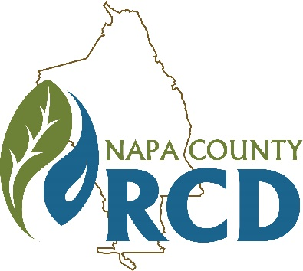 | Napa County Resource Conservation District  Special Meeting of the Board of Directors  When: Monday, June 22, 2020 at 10:00 A.M.  Where: Tele/videoconference
Jim Lincoln | Ashley Anderson Bennett | Rainer Hoenicke | Jon Kanagy | Beth Painter | Bill Pramuk | Gretchen Stranzl McCann
President | Vice President | Director | Director | Director | Director | Director

Lucas Patzek | Anna Mattinson | Shana Bagley | Tracy Schulze
Executive Director | District Secretary | District Counsel | Auditor-Controller

GENERAL INFORMATION
The Napa County Resource Conservation District (RCD or District) will hold a special meeting of its Board of Directors on Monday, June 22, 2020 at 10:00 A.M. Under the Governor’s Executive Orders N-25-20 and N-29-20, which suspend some requirements of the Brown Act (Gov. Code § 54950, et seq.) in an effort to mitigate the impact of COVID-19, this meeting will be held only via videoconference and teleconference. The public may participate in the meeting remotely via Zoom videoconference at: https://us02web.zoom.us/j/2237373265?pwd=cTBEYVFOOUtocnZvQTNFT21GVmN5QT09
(Meeting ID: 223 737 3265, Password: 1303), or via teleconference at: 669-900-9128, Meeting ID: 223 737 3265. We will only accept written public comments received by 9 A.M. on Monday, June 22, 2020. All comments must be sent by email to Lucas@NapaRCD.org. All comments will be considered a public record and will be put into the meeting record. Requests for disability related modifications or accommodations, aids or services must be made to the District office no less than 24 hours prior to the meeting date by contacting 707-690-3110, anna@naparcd.org. All materials relating to the agenda are available for public inspection at the District office Monday through Friday, between the hours of 8:00 A.M. and 5:00 P.M., except for District Holidays. The agenda is available online at: http://naparcd.org/

1. | CALL TO ORDER, ROLL CALL
- Roll Call – The meeting is to be called to order by the Chair at 10:00 A.M., and the District Secretary will take attendance.
2. | PUBLIC COMMENTS
In this time-period, anyone may comment to the Board regarding any subject over which the District has jurisdiction. No comments will be allowed involving any subject matter scheduled for hearing, action, or discussion as part of the current agenda other than to request discussion on a specific consent item. Individuals are requested to limit their comment to three minutes. No action will be taken by the Board as a result of any item presented at this time.
3. | NEW BUSINESS
- Authorization for Executive Director to Sign Agreement Number 2CA05026 with the California Department of Forestry and Fire Protection. Lucas Patzek & Jim Lincoln
California Department of Forestry and Fire Protection (CAL FIRE) wishes to enter into an agreement with the RCD to more effectively increase the pace and scale of critical forest management at the landscape level within the area of the RCD’s influence. Work will be completed over a two (2) year timeline and work product deliverables will include reports, surveys and scoping efforts as required to complete environmental compliance, per CAL FIRE policy and procedures and all applicable laws. The maximum amount of this agreement is $200,000, and the agreement is effective through June 30, 2022.
4. | ADJOURNMENT

