SPECIAL AGENDA
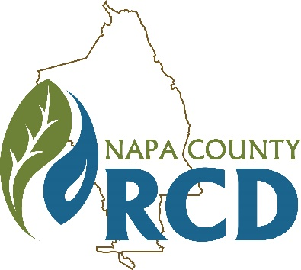 | Napa County Resource Conservation District  Special Meeting of the Finance Committee  When: Tuesday, May 12, 2020 at 10:00 A.M.  Where: Tele/videoconference
Jim Lincoln | Rainer Hoenicke | Bob Zlomke
Chair | Member | Member

Lucas Patzek | Anna Mattinson | Tracy Schulze
Executive Director | District Secretary | District Auditor

GENERAL INFORMATION

The Napa County Resource Conservation District (RCD or District) will hold a special meeting of the Finance Committee of the Board of Directors on Monday, May 12, 2020 at 10:00 A.M. Under the Governor’s Executive Orders N-25-20 and N-29-20, which suspend some requirements of the Brown Act (Gov. Code § 54950, et seq.) in an effort to mitigate the impact of COVID-19, this meeting will be held only via videoconference and teleconference. The public may participate in the meeting remotely via Zoom videoconference at: https://zoom.us/j/200678426?pwd=Um0wWU50T3kzcUtMTWJjRXVQalBTdz09 (Meeting ID: 223 737 3265, Password: 1303), or via teleconference at: 669-900-9128, Meeting ID: 223 737 3265. We will only accept written public comments received by 9 A.M. on Tuesday, May 12, 2020. All comments must be sent by email to Lucas@NapaRCD.org. All comments will be considered a public record and will be put into the meeting record. Requests for disability related modifications or accommodations, aids or services must be made to the District office no less than 24 hours prior to the meeting date by contacting 707-815-4349, anna@naparcd.org. All materials relating to the agenda are available for public inspection at the District office Monday through Friday, between the hours of 8:00 A.M. and 5:00 P.M., except for District Holidays. The agenda is available online at: http://naparcd.org/

1. | CALL TO ORDER, ROLL CALL
- Roll Call – The meeting is to be called to order by the Chair at 10:00 A.M., and the District Secretary will take attendance.
- Approval of the Agenda – The Board will consider approval of the agenda for this meeting.
- Approval of Meeting Minutes – The Board will consider approval of minutes from the March 30, 2020 special meeting.
2. | PUBLIC COMMENTS
In this time-period, anyone may provide comment to the Finance Committee, including requests for consideration of items to be placed on future agendas and announcements by District directors and staff. No action will be taken on non-agenda items.
3. | NEW BUSINESS
- Review and Discuss District Financial Reports. Anna Mattinson & Lucas Patzek
The Q3 revenue and expense report will be presented, and a FY 2019-2020 budget adjustment will be presented.
- Review and Discuss Fiscal Year Budget for 2020-2021. Lucas Patzek
The Fiscal Year Budget for 2020-2021 will be presented.
4. | ADJOURNMENT

Next Meetings:
- September 3, 2020 at 9:00 AM
- Nov. 5, 2020 at 9:00 AM

