SPECIAL AGENDA
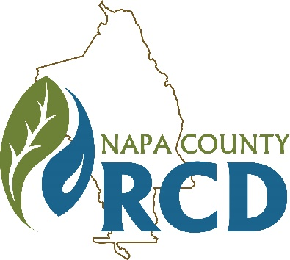 | Napa County Resource Conservation District  Finance Committee of the Board of Directors  When: Wednesday, December 4, 2019 at 9:00 A.M.  Where: 1303 Jefferson St., Suite 500B, Napa, CA
Jim Lincoln | Rainer Hoenicke | Bob Zlomke
Chair | Member | Member

Lucas Patzek | Anna Mattinson | Tracy Schulze
Executive Director | District Secretary | District Auditor

GENERAL INFORMATION

The Napa County Resource Conservation District (RCD or District) will hold a special meeting of the Finance Committee of the Board of Directors on Wednesday, December 4, 2019 at 9:00 A.M. at 1303 Jefferson St., Suite 500B, Napa, CA. The meeting room is wheelchair accessible. Assistive listening devices and interpreters are available through the Secretary of the Board. Requests for disability related modifications or accommodations, aids or services must be made to the District office no less than 24 hours prior to the meeting date by contacting 707-690-3110, anna@naparcd.org. Time for public commentary will be provided. Time limitations for individual speakers may be set at the discretion of the Chair. All materials relating to the agenda are available for public inspection at the District office Monday through Friday, between the hours of 8:00 A.M. and 5:00 P.M., except for District Holidays. The agenda is available online at: http://naparcd.org/ .

1. | CALL TO ORDER, ROLL CALL
- Roll Call – The meeting is to be called to order by the Chair at 9:00 A.M., and the District Secretary will take attendance.
- Approval of the Agenda – The Board will consider approval of the agenda for this meeting.
- Approval of Meeting Minutes – The Board will consider approval of minutes from the May 29, 2019 special meeting.
2. | PUBLIC COMMENTS
In this time-period, anyone may provide comment to the Finance Committee, including requests for consideration of items to be placed on future agendas and announcements by District directors and staff. No action will be taken on non-agenda items.
4. | UNFINISHED BUSINESS
There is no unfinished business.
5. | NEW BUSINESS
- Review and Discuss FY2018-2019 Audit. Lucas Patzek & Tracy Schulze
The FY 2018-2019 audit has been completed by Larry Bain, CPA. We will review and discuss any findings.
- Review and Discuss District Financial Report. Anna Mattinson & Lucas Patzek
The Q1 revenue and expense report will be presented.
- Review and Discuss Fixed Asset List. Lucas Patzek
The RCD’s fixed asset list contains several fully depreciated items which need to be removed by Board action.
6. | ADJOURNMENT

