AGENDA
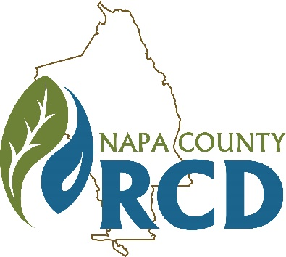 | Napa County Resource Conservation District  Special Meeting of the Board of Directors  When: Tuesday, December 17, 2019 at 9:00 A.M.  Where: Napa Valley College, Community Room  2277 Napa Vallejo Hwy, Napa, CA 94558
Jim Lincoln | Ashley Anderson Bennett | Rainer Hoenicke | Jon Kanagy | Beth Painter | Bill Pramuk | Gretchen Stranzl McCann
President | Vice President | Director | Director | Director | Director | Director

Lucas Patzek | Anna Mattinson | Shana Bagley
Executive Director | District Secretary | District Counsel

GENERAL INFORMATION

The Napa County Resource Conservation District (RCD or District) will hold a special meeting of its Board of Directors on Tuesday, December 17, 2019 at 9:00 A.M.-4:30 P.M. The meeting will be held in the Community Room of the Napa Valley College located at 2277 Napa Vallejo Hwy, Napa, CA 94558. Food and beverages will be served. The meeting room is wheelchair accessible. Assistive listening devices and interpreters are available through the Secretary of the Board. Requests for disability related modifications or accommodations, aids or services must be made to the District office no less than 72 hours prior to the meeting date by contacting 707-690-3110, anna@naparcd.org. Time for public commentary will be provided prior to Consent Calendar. Time limitations for individual speakers may be set at the discretion of the Chair. All materials relating to the agenda are available for public inspection at the District office Monday through Friday, between the hours of 8:00 A.M. and 5:00 P.M., except for District Holidays. The agenda is available online at: http://naparcd.org/ .

1. | CALL TO ORDER, ROLL CALL
- Roll Call – The meeting is to be called to order by the Chair at 9:00 A.M., and the District Secretary will take attendance.
2. | PUBLIC COMMENTS
In this time-period, anyone may comment to the Board regarding any subject over which the District has jurisdiction. No comments will be allowed involving any subject matter scheduled for hearing, action, or discussion as part of the current agenda other than to request discussion on a specific consent item. Individuals are requested to limit their comment to three minutes. No action will be taken by the Board as a result of any item presented at this time.
3. | NEW BUSINESS
- RCD Strategic Planning. Board of Directors & Staff
RCD Directors and Staff will undertake a strategic planning discussion to outline organizational strategies and high-level goals. This discussion will be facilitated by consultant Amy Stork.
4. | ADJOURNMENT

