|  |  |
| --- | --- |
| AGENDA | |
|  | Napa County Resource Conservation District  Special Meeting of the Huichica Creek Sustainable Vineyard and Orchard Advisory Committee  **When**: Thursday, September 5, 2019 at 8:00 A.M.  **Where**: 1303 Jefferson St., Suite 500B, Napa, CA |
| |  |  |  |  |  | | --- | --- | --- | --- | --- | | Jim Lincoln | Ashley Anderson Bennett | Bill Pramuk | Margaret Woodbury | Bob Zlomke | | **President** | **Vice President** | **Director** | **Associate Director** | **Associate Director** | |  | | | | | | |
| |  |  | | --- | --- | | Lucas Patzek | Miguel Garcia | | **Executive Director** | **Sustainable Agriculture**  **Program Manager** | | |

|  |
| --- |
| **COMMITTEE PURPOSE**  Resolution 2016-07 of the Board of Directors of the Napa County Resource Conservation District (RCD or District) established the Huichica Creek Sustainable Vineyard and Orchard Advisory Committee (Committee) to provide input related to the operation and long-term goals of the RCD’s program.  **GENERAL INFORMATION**  The RCD will hold a special meeting of the Committee on Thursday, September 5, 2019 at 8:00 A.M. The meeting will be held at the Napa County RCD Office 1303 Jefferson St #500B Napa, CA 94559. The site is wheelchair accessible. Assistive listening devices and interpreters are available through the Secretary of the Board. Requests for disability related modifications or accommodations, aids or services must be made to the District office no less than 72 hours prior to the meeting date by contacting 707-690-3110, anna@naparcd.org. Time for public commentary will be provided prior to Consent Calendar. Time limitations for individual speakers may be set at the discretion of the Chair. All materials relating to the agenda are available for public inspection at the District office Monday through Friday, between the hours of 8:00 A.M. and 5:00 P.M., except for District Holidays. The agenda is available online at: <http://naparcd.org/> |

|  |  |
| --- | --- |
| 1. | CALL TO ORDER, ROLL CALL |

1. **Roll Call**The meeting is to be called to order and attendance taken by the Chair at 8:00 A.M.
2. **Approval of the Agenda**The Committee will consider approval of the agenda for this meeting.
3. **Approval of Meeting Minutes**The Committee will consider approval of minutes from its July 18, 2019 meeting.

|  |  |
| --- | --- |
| 2. | PUBLIC COMMENTS |

In this time-period, anyone may comment to the Board regarding any subject over which the District has jurisdiction. No comments will be allowed involving any subject matter scheduled for hearing, action, or discussion as part of the current agenda other than to request discussion on a specific consent item. Individuals are requested to limit their comment to three minutes. No action will be taken by the Board as a result of any item presented at this time.

|  |  |
| --- | --- |
| 3. | UNFINISHED BUSINESS |

There is no unfinished business scheduled.

|  |  |
| --- | --- |
| 4. | NEW BUSINESS |

1. **Current Activities at HCV.** *Miguel Garcia & Lucas Patzek*

Discuss items including: Grape purchase agreements with Cakebread and Leaf & Vine, agreement to donate apples to Will Drayton in exchange for apple tree pruning and management, outcomes of the 8/27/19 irrigation efficiency workshop, and outcomes from meeting with Watershed Materials.

1. **Upcoming Vineyard Management Needs.** *Miguel Garcia*

Discuss items including:Plan for managing vineyard over the next growing season, plan for removing Block D, irrigation system upgrades, managing diseased vines, relocating the mix and load station further from the creek, and building structure(s) at the property.

|  |  |
| --- | --- |
| 5. | ADJOURNMENT |

**HCV Block Map**

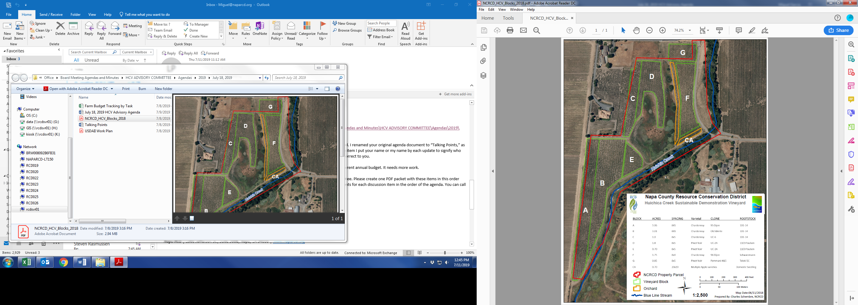

**HCV Grape Sales, $**

**HCV Grape Yields, Tons**