Napa River Watershed
Steelhead and Salmon Monitoring Program
www.naparcd.org

What is monitored?
The Napa County Resource Conservation District (RCD) conducts fish monitoring in the Napa River watershed to collect information about native fish populations with emphasis on two salmonid species - steelhead trout (Oncorhynchus mykiss) and Chinook salmon (Oncorhynchus tshawytscha). This monitoring program includes capturing and counting juvenile salmonids as they migrate to the ocean as “smolts”, counting adult fish and mapping their spawning distributions, observing juveniles through snorkeling surveys, and long-term tracking of individual fish with implanted tags. Results and reports are available at www.naparcd.org.
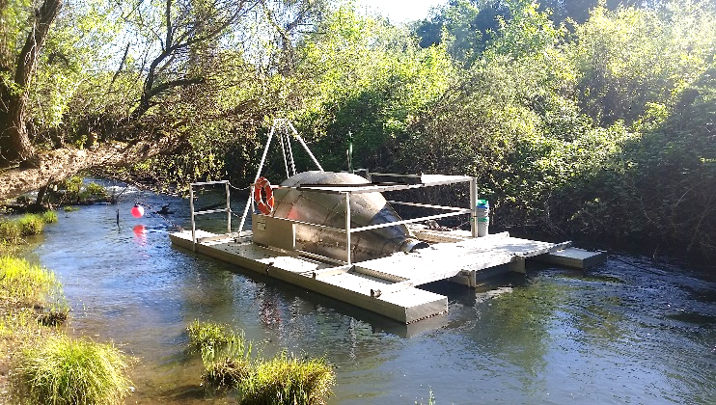
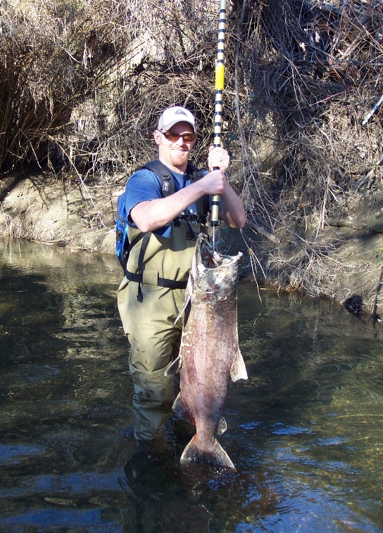

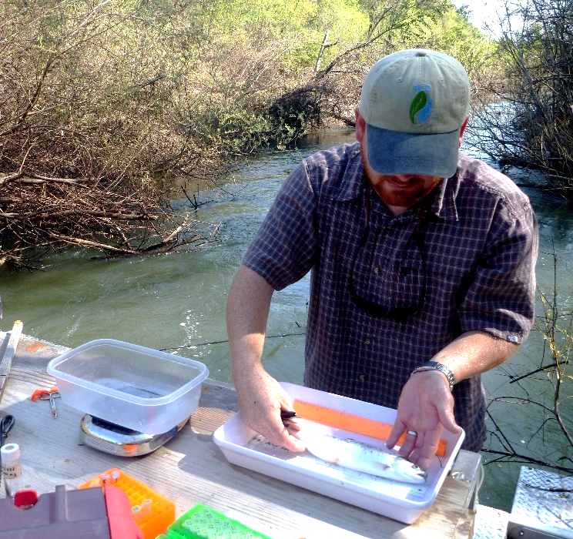

Clockwise from top left: Napa River rotary screw trap, Chinook salmon carcass recovered during a spawner survey, snorkel surveying for juvenile salmonids, measuring and tagging a steelhead smolt from the Napa River.
Focus Species - Steelhead
Steelhead in the Napa River watershed are part of the Central California Coast distinct population segment (DPS), which is listed as Threatened under the US Endangered Species Act. The listing was based on a long-term decline in steelhead abundance throughout the DPS, which stretches from just north of Ukiah south to Santa Cruz and includes all streams tributary to the San Francisco Estuary.

Adult steelhead return to the Napa River to spawn in the winter and spring, typically between January and March. In wet years with abundant spring-season rainfall, adult fish have been observed spawning as late as May. Steelhead spawning is difficult to document in natural river systems because adults migrate primarily at night and spawn during winter storm flows when visibility is low. Therefore, not much is known about the specific movement patterns of adult steelhead in the Napa River watershed. In order to maximize access to steep and often intermittent streams, adult fish will migrate upstream on the receding limbs of winter storm flows. In dry years, access to tributary streams can be limited or completely blocked. RCD has documented steelhead spawning in the mainstem Napa River, mostly in dry years when access to more favorable tributary spawning habitat is limited by low streamflow.

Adult female steelhead captured and released in the Napa River rotary screw trap (April 2, 2013)

Juvenile steelhead remain in freshwater for one or more years before migrating to the ocean as smolts (see pictures below). Juveniles (also called parr) typically remain in cool, shady streams with perennial flow for up to three years where they attain lengths of around 125 to 200 millimeters (about five to eight inches) before smolting. During their freshwater growth phase, juvenile steelhead feed mostly on aquatic and terrestrial invertebrates and may move around within a stream and between streams at higher flows to seek out suitable habitat.

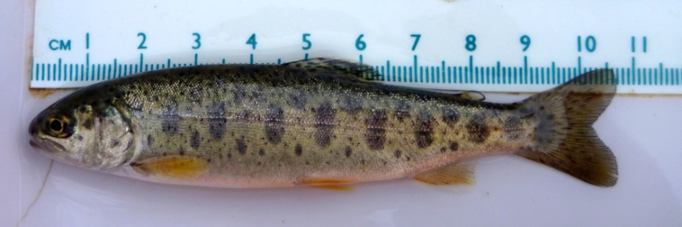
Typical Napa River steelhead parr with a fork length around 100millimeters (approximately 4 inches)

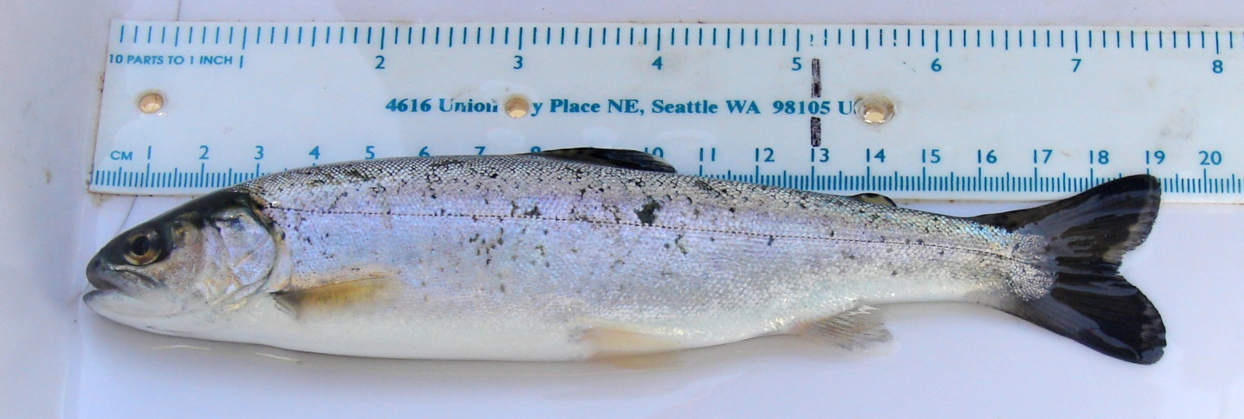
Typical Napa River steelhead smolt with a fork length around 185millimeters (approximately 7 inches)

Focus Species - Chinook salmon
Little is known about the historical abundance and distribution of Chinook salmon in the Napa River watershed (Leidy et al., 2005). Based on accounts of the Napa River’s historical conditions and its proximity to the entrance to the Sacramento/San Joaquin River systems, it is likely that the watershed once supported a relatively large, sustainable population of Chinook salmon (Stillwater Sciences, 2002). Napa River salmon populations were not well documented during the early twentieth century and may have been extinguished completely for some period of time. During the last decade, however, juvenile salmon have been regularly collected in the Napa River, and adult spawning has been observed in most years, suggesting that a process of recolonization may be underway.

The Napa River Chinook salmon population is not included in either of the nearby Chinook salmon Evolutionarily Significant Units (ESU): the Central Valley Fall/Late Fall Run and the California Coastal Chinook Salmon ESUs. However, recent genetic analysis of Napa River Chinook samples found that ancestry of Chinook salmon from the Napa River is primarily from the Central Valley Fall/Late Fall Run (Garza and Crandall, 2013).

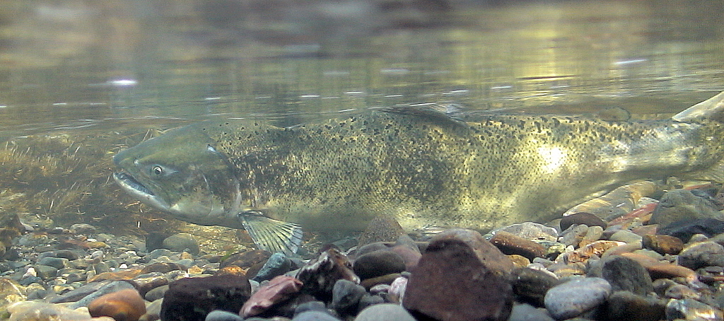
Adult female Chinook salmon on spawning nest (i.e. redd) in the Napa River (2006)

Chinook salmon enter the Napa River to spawn in the fall, typically around late September and early October. Adult fish will hold in the lower river and estuary for a month or more waiting for the first rains of the season. In some years, when these first rains do not arrive until early winter, salmon migrations are completely blocked and the fish presumably perish in the estuary or swim back out to the estuary to try another stream. In a more typical year, adult salmon swim immediately upstream with the first rains and stake out suitable spawning areas. Salmon quickly find mates and construct spawning nests (i.e. redds) in the streambed gravels and cobbles, typically within a day or two (see picture above). After spawning, spent salmon will remain in the area for up to several weeks protecting their redds until they ultimately die. Peak Chinook spawning activity in the Napa River occurs from late November through early January.

Juvenile Chinook salmon spend several months rearing in the Napa River from January through June. Juveniles feed primarily on invertebrates during their freshwater rearing phase, which can last from two to five months. Chinook salmon smolts are typically 80 to 100 millimeters long (approximately three to four inches) when they leave the river and enter the estuary (see picture below). Outmigration occurs throughout the spring with a peak occurring in May.

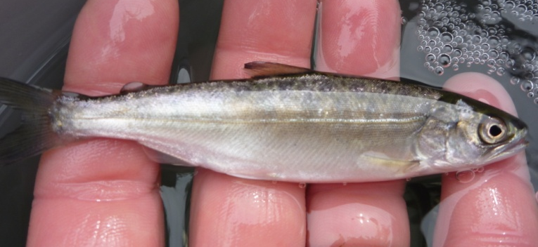
Typical Napa River Chinook salmon smolt with a fork length of 90 millimeters (approximately 3.5 inches)

Where do salmon and steelhead live and where do we monitor them?
The mainstem Napa River provides approximately 30 miles of viable salmonid spawning habitat, and there are approximately 141 miles of tributary streams that support salmonid spawning and rearing. In addition, the tidal reaches of the mainstem and several tributaries provide feeding and rearing habitat for salmonids transitioning from freshwater and the saltwater.

The RCD has deployed an 8-foot diameter rotating fish trap (aka rotary screw trap) in the lower Napa River each year since 2009 to capture young steelhead and salmon as they leave for the estuary and ocean. Additional surveys for adult salmon and steelhead are conducted in the mainstem Napa River and tributary streams as funding and flow conditions allow.

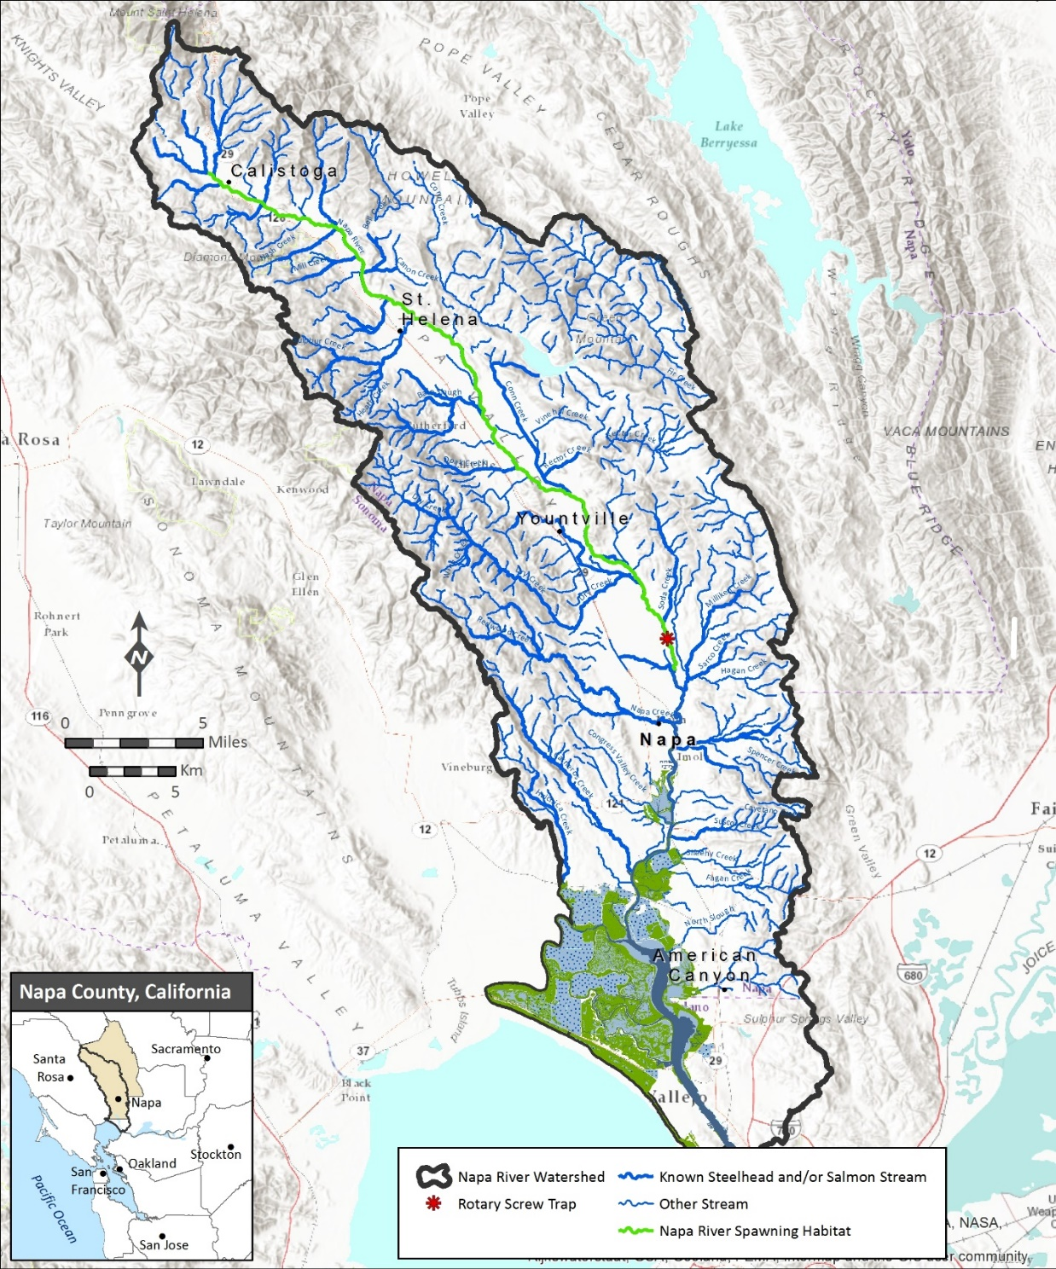

What other types of fish live in the Napa River?
As of 2019, we have documented 32 fish species in the rotary screw trap, and these are just the species that occur in the freshwater portion of the river. Many more fish species live in the lower part of the river and estuary. Of the 32 fish species we have captured, several have only been encountered once or twice, suggesting that their populations are very small, they are less susceptible to being caught, or our sampling location is at the edge of their natural range (i.e. freshwater/saltwater transition).

Does the Napa River support mostly native or non-native fish?
Of the 28 freshwater fish species regularly captured in the rotary screw trap since 2009, 14 were native and 14 were non-native. However, native species accounted for over 90% of the total catch in all sampling years. These results suggest that, although non-native species are present, the fish community is comprised mostly of native species.

How many adult steelhead and salmon spawn in the Napa River watershed each year?
The number of adult steelhead in any given year is likely quite variable and still not well known due to a lack of data. Based on the limited number of steelhead spawning observations during the past 15+ years, along with the rotary screw trap dataset, a reasonable estimate may be somewhere between a few hundred to perhaps a thousand individuals, but this is a very rough approximation. The number of adult Chinook salmon spawning in a given year appears to be even more variable, cycling between years of relatively high abundance and years with very few or no fish observed. A much more robust monitoring effort with stable funding would be needed to accurately estimate adult spawner numbers.

Are there trends in steelhead and salmon abundance over time?
Steelhead smolts have been consistently collected in all sampling years since 2009. There was a notable decline in steelhead smolt catch during the drought years of 2013-2016. The highest steelhead catches have been during wet years and the lowest catches during dry years, suggesting a strong dependence on rainfall and streamflow patterns. Juvenile Chinook salmon population data do not show any apparent trends since sampling began in 2009. The salmon population in Napa appears to be small and opportunistic, with the highest spawning abundances occurring during years with adequate rainfall in fall and early winter.

What is the average size and condition of steelhead smolts leaving the watershed?
Napa River steelhead smolts have been consistently large in all sampling years, with an average length of about 190 millimeters (7.5 inches). It is well-documented in the scientific literature that larger salmonid smolts have a significant survival advantage in the ocean and return to spawn at much higher rates than smaller smolts. Based on the size of our smolts and existing literature, we estimate ocean survival may be as high as 25%, meaning that perhaps one in every four smolts returns to the Napa River as an adult.

What are the origins of steelhead and salmon in the Napa River?
The Napa River steelhead population is entirely wild and self-sustaining, since no artificial stocking efforts of hatchery-raised steelhead occurs in the watershed. The exact origins of Chinook salmon in the watershed are not as well-known, as described previously in the “Focus Species” section. RCD is collaborating with CDFW and UC Davis to use genetics and otolith analysis to determine if the Chinook salmon we observe in the Napa River watershed are strays from other river systems or have established a local population. This effort has proven difficult due to lack of funding and the relatively small number fish available to sample in any given year.

Are habitat restoration efforts increasing steelhead and salmon counts?
With sufficient time (perhaps 15-20 years), we should be able to assess whether ongoing restoration efforts are affecting the number of steelhead and salmon smolts being produced. Large-scale restoration and fish passage barrier removal projects take time to achieve their intended ecological benefits. Based on this reality, we simply have not been monitoring long enough to gauge the effects of these projects on fish populations in a meaningful way.

How does drought affect steelhead, salmon, and other native fishes?
Drought conditions are especially hard on salmonids because they require cool, well-oxygenated water. From 2013-2016 we we observed a notable decline in the number of salmonids captured in the rotary screw trap. For steelhead, these declines suggest that the drought reduced the amount of summer rearing habitat available and thus limited their production. For Chinook, dry conditions in the fall during these same years completely prevented adults from migrating upstream to spawn. Other native fishes are well-adapted to California’s warm dry summers and appear to have survived the drought just fine.

How long has monitoring been done, and how long should it continue?
The rotary screw trap has been operated annually in the same location since 2009. Adult spawner surveys have not been conducted consistently, but regular surveys have been made since 2003 in several restoration reaches of the Napa River. Other monitoring has been completed opportunistically as funding was available over shorter time periods and in various locations throughout the watershed.

Ideally, fish monitoring should be conducted with approximately the same level of effort every year for at least three to four life-cycles of the target species. For steelhead and salmon, which live an average of four to six years, this means that monitoring for approximately 20 years would provide sufficient data to determine their population status and trends. Long-term fish count data are extremely limited for streams in the bay area; therefore, the longer this type of monitoring is continued, the more valuable it becomes.

How much does monitoring cost and who pays for it?
Funding for fish monitoring has come from a number of sources including the California Department of Fish and Wildlife, NOAA’s National Marine Fisheries Service, the California Coastal Conservancy, California Department of Water Resources, the County of Napa, The Peter A. & Vernice H. Gasser Foundation, Napa River Steelhead, the Napa County Wildlife Conservation Commission, Napa Valley Vintners, and donations from individuals.

The cost to implement the current fish monitoring program varies from year to year based on funding availability and whether natural environmental conditions (e.g. rainfall and streamflow patterns) are favorable for surveying. The total annual program cost is $50,000 to $75,000, depending on the length of the rotary screw trap season and number of spawner surveys conducted. Approximately 10-20% of the total cost is provided by in-kind donations of time and services from volunteers and project partners.

Who is involved?
The Napa RCD coordinates and runs the program with volunteer assistance from local citizens. Other project partners include Treasury Wine Estates, which provides RCD with river access and logistical assistance, and the Napa County Flood Control and Water Conservation District, which assists with landowner access. All of the funders listed above are also project partners and have greatly helped develop and shape the program over the years.

Literature Cited
Garza, J.C., and E.D. Crandal. 2013. Genetic Analysis of Chinook Salmon from the Napa River, California. Fisheries Ecology Division Southwest Fisheries Science Center and the Institute of Marine Sciences, University of California, Santa Cruz.

Leidy, R.A., G.S. Becker, and B.N. Harvey. 2005. Historical distribution and current status of steelhead/rainbow trout (Oncorhynchus mykiss) in streams of the San Francisco Estuary, California. Center for Ecosystem Management and Restoration, Oakland, California.

Stillwater Sciences and W.E. Dietrich. 2002. Napa River basin limiting factors analysis. Technical report. Prepared by Stillwater Sciences and W. E. Dietrich, Berkeley, California for the San Francisco Regional Water Quality Control Board and California State Coastal Conservancy.

Further Information
For additional information on the RCD’s fish monitoring program, please visit the RCD’s website at www.naparcd.org or contact:
Jonathan Koehler
Senior Biologist
jonathan@naparcd.org
(707) 690-3118
Napa County Resource Conservation District
1303 Jefferson St. Suite 500B
Napa, California 94559

